Reference: <https://www.youtube.com/watch?v=Y3jwM9Zkmu0&list=PLWPirh4EWFpEQB2XB_EdbrQwTEXYm0GS2&index=3>

Whenevr you creta e some service it will be only accessible by web services not by the Windows applications and for mobiles for this to make web services available for all platform wcf is used.

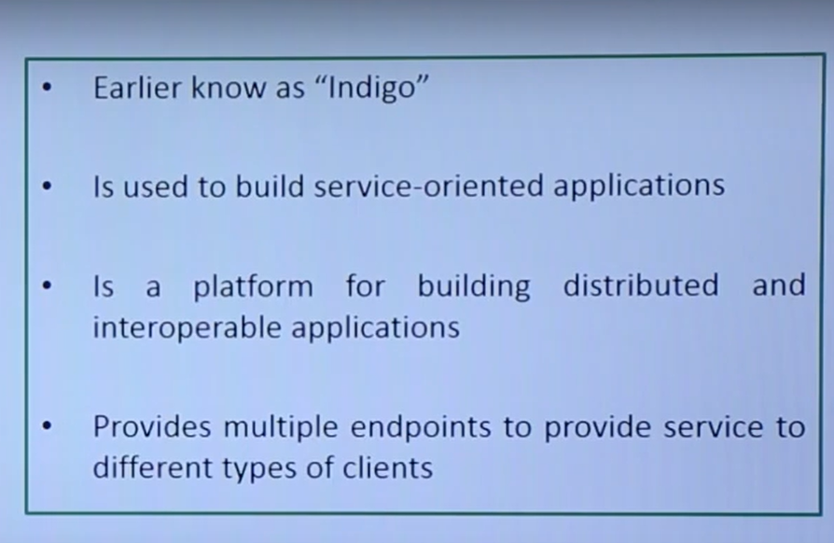

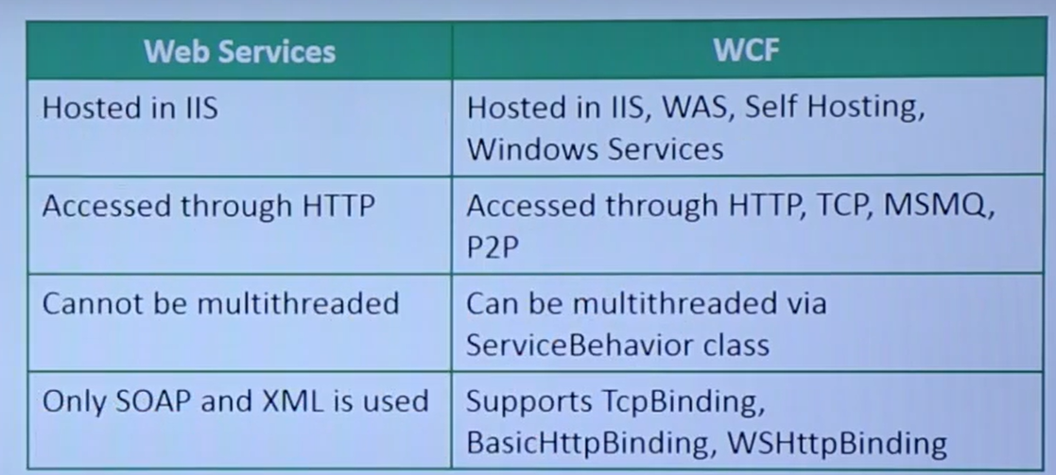

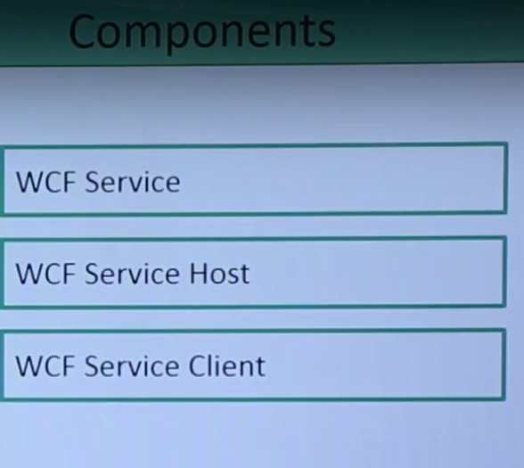

**ABC of WCF:**  single service may have multiple end points in order to server different kind of clients like for Web, windows and for mobile

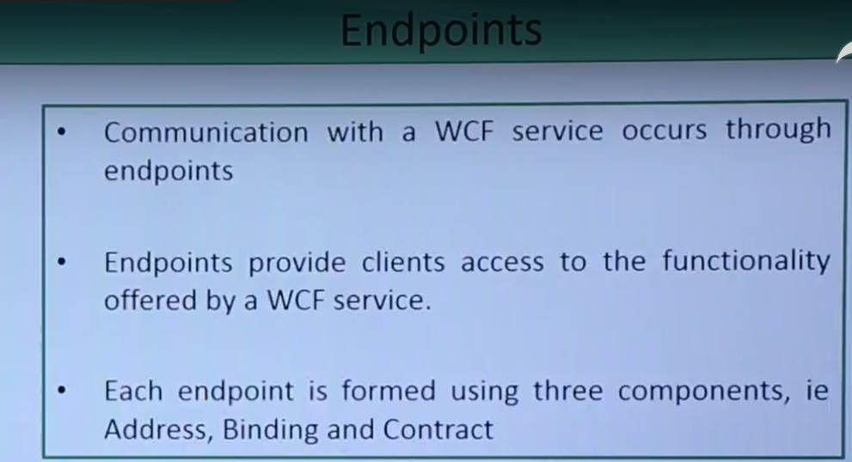

When we create wcf service you’ll put some methods those are the functionalities offered by the wcf that may be accesed by clients through end points.

But for preparing end points we need A B C: address binding conrtact

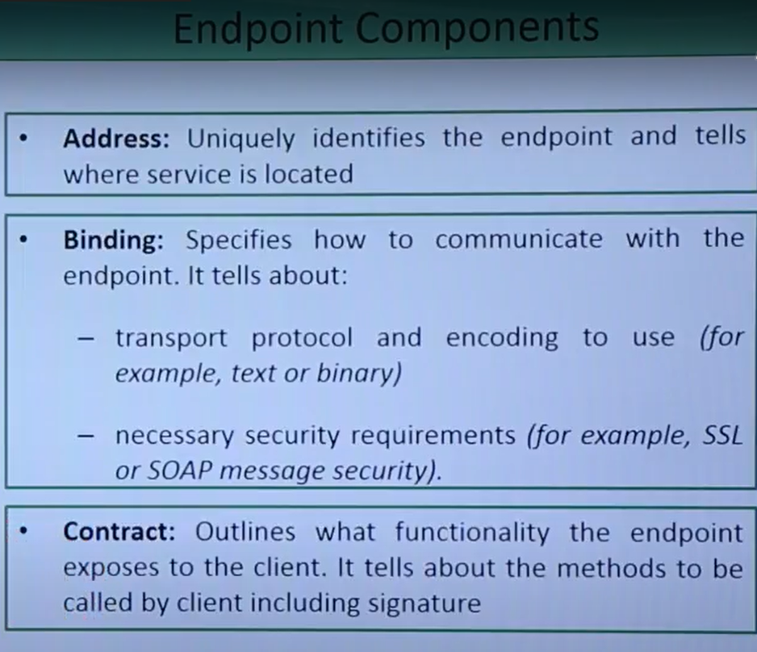

Address: at some service in particular server or IP address with port number the service could be located. We can access it using address

Wcf provides different type of communication like http, tcp etc on the basis of this we have different binding

Ssl: secured socket layer

When we create service, we create some no of contracts like service contact, operation contact, those contract will tell what is the structure of wcf service and what are functionalities we are going to provide.

When we create method in c# it has aa signature, that signature will be described by service contact and later method will be defined by the operations contract.

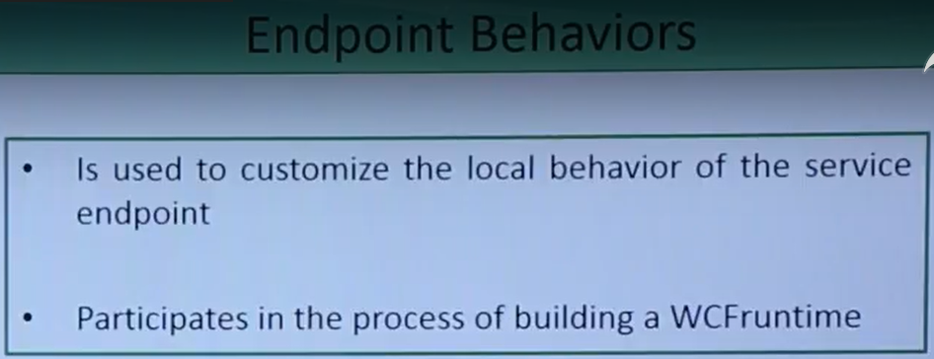:

Endpoints behaiviour used to make the customization to the endpoint at the runtime.

When you’ll be deploying it this end point behavior will be in the action at that particular time

Bindings:

Binding essenetial component of end point

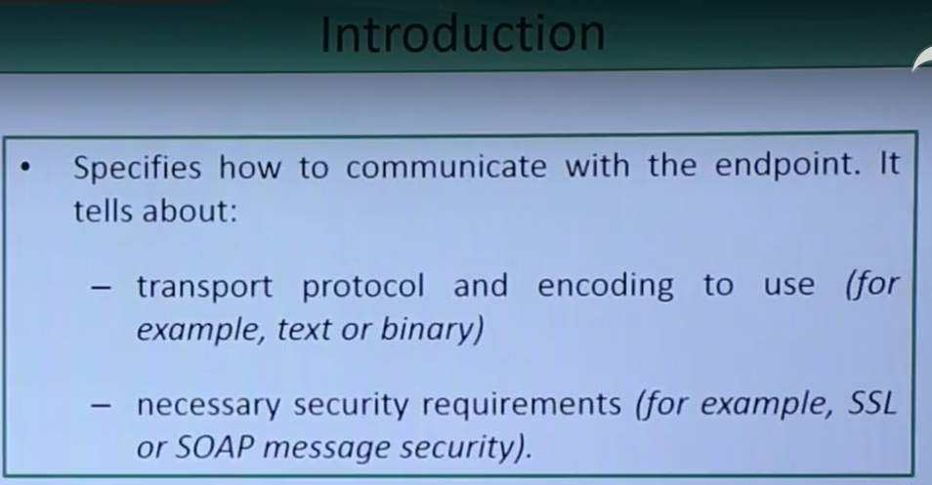

Creating wcf project in visual studio:

<https://www.youtube.com/watch?v=wxJ2gUrhptc&t=220s>

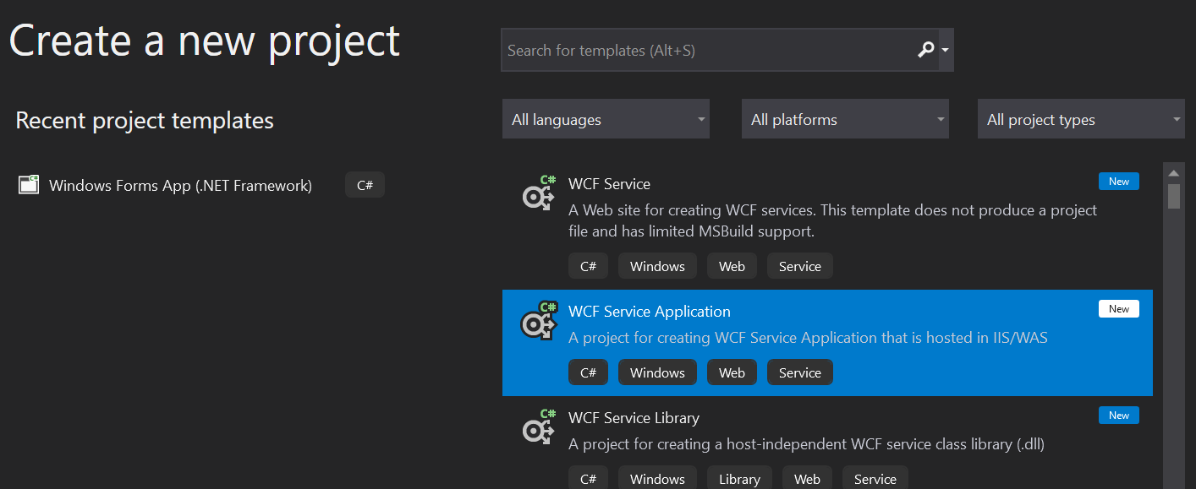

New project:

Create new project-> search Class Libray-> select on class library(.Net framework) click ok create.

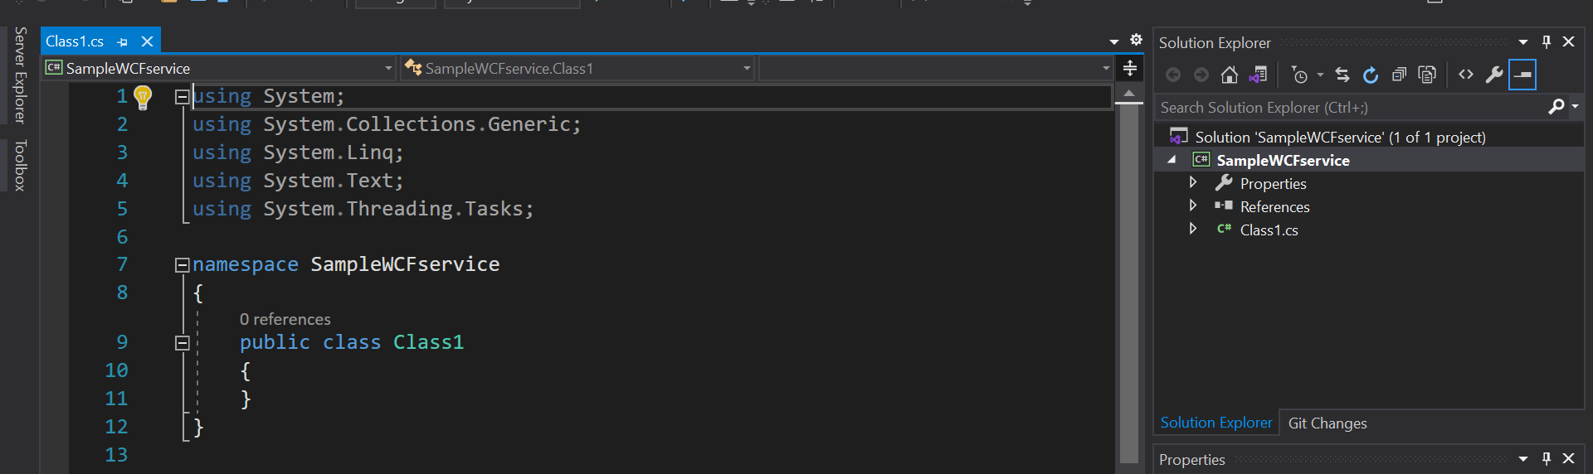

This will be created.

Next add reference: which is system.servicemodel

Right click on references-> add references

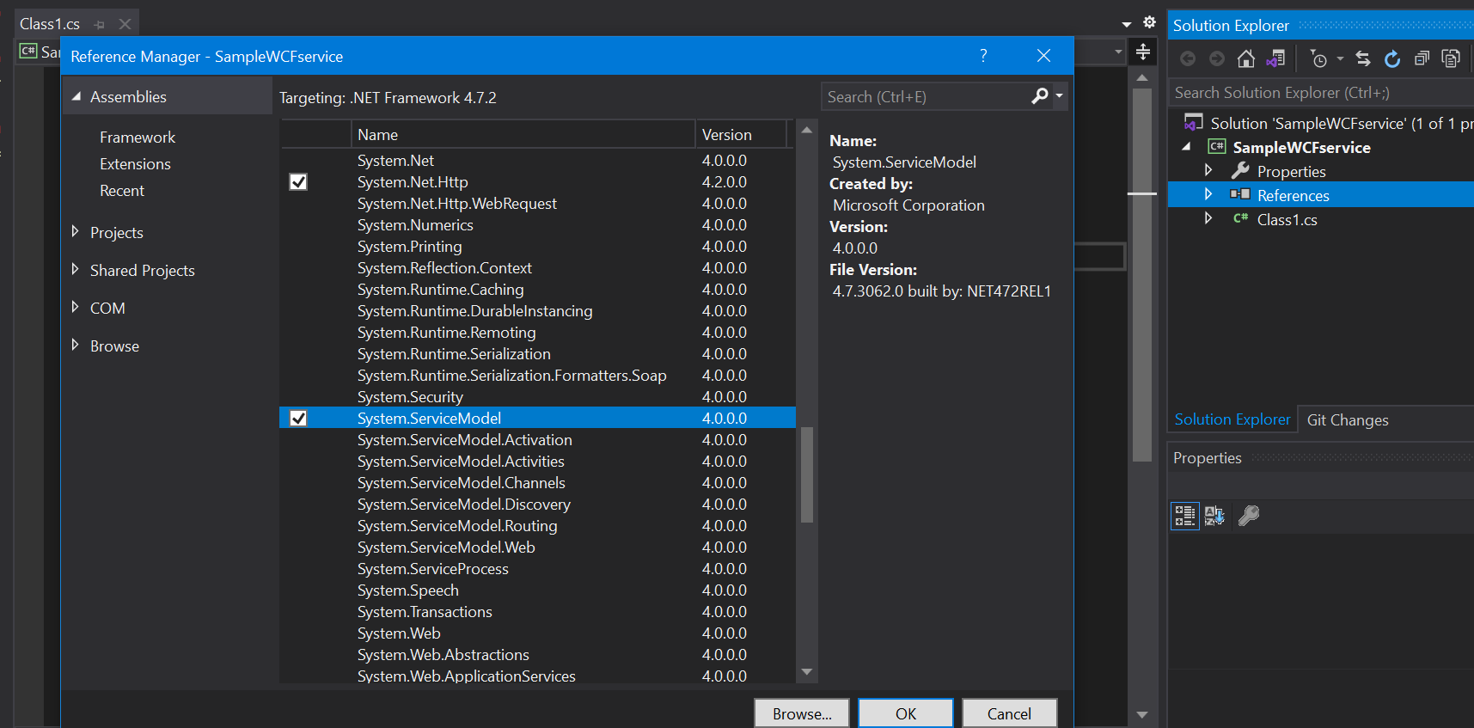

Include it in code also

To add contract:

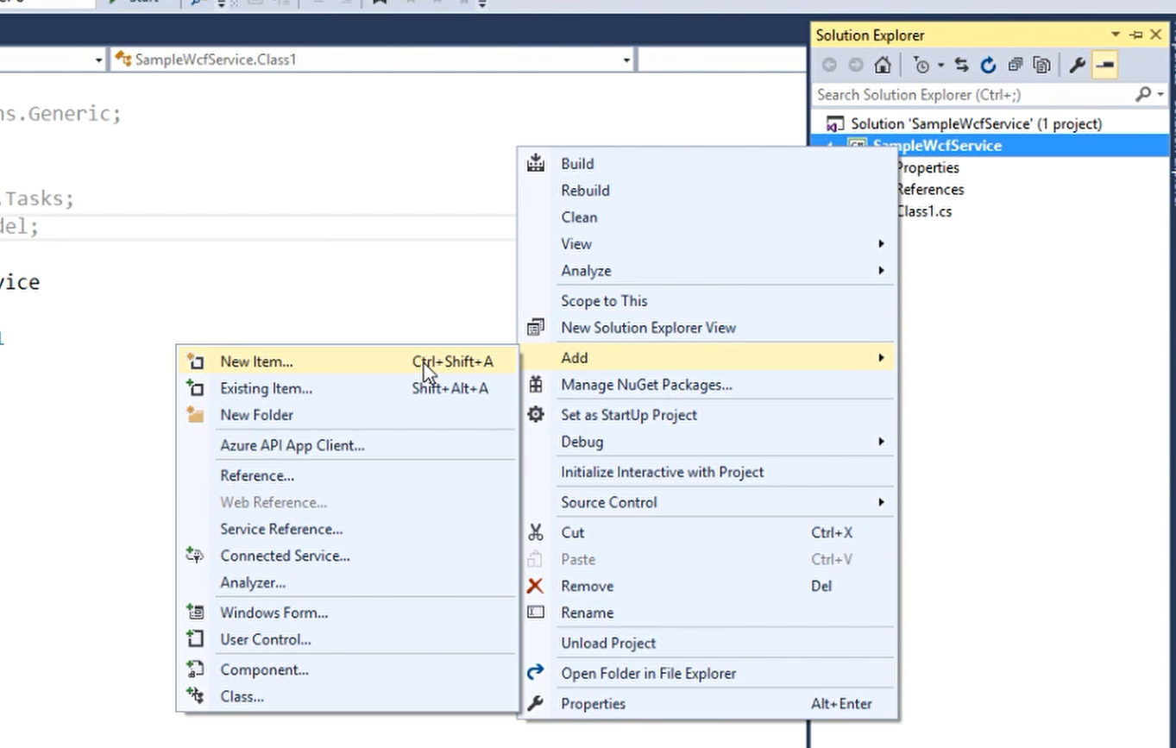

SELECT INTERFACE THERE:

NAME IT Iuser.cs

Add attribute servicecontract to iuser.cs

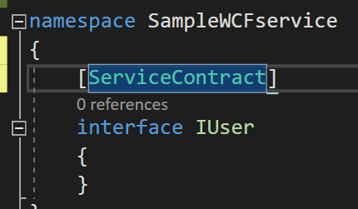

With this it will give structure to wcf service, and this interface itself will provide you the methods which will be given by the wcf service and as I’ll use this interface outside project I need to mak e it public

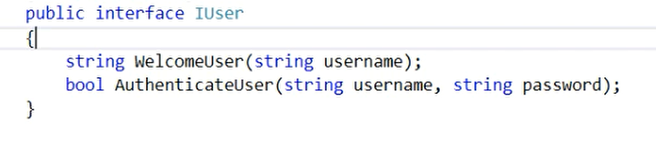

Create 2 methods which I want to expose it to user add operationscontract

Change name of class1.cs to User.cs

It shows red line on Iuser:

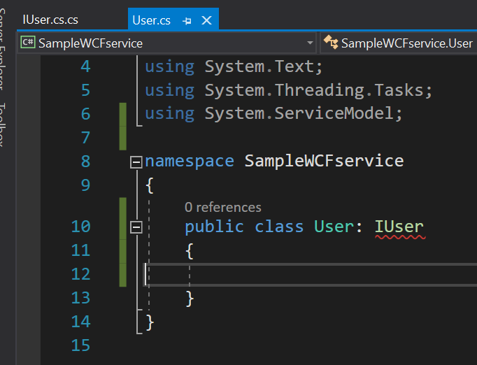

Hover cursor on Iuser:

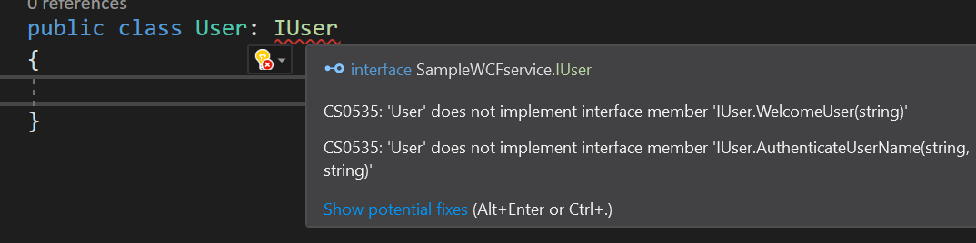

Press on show potential fixes:

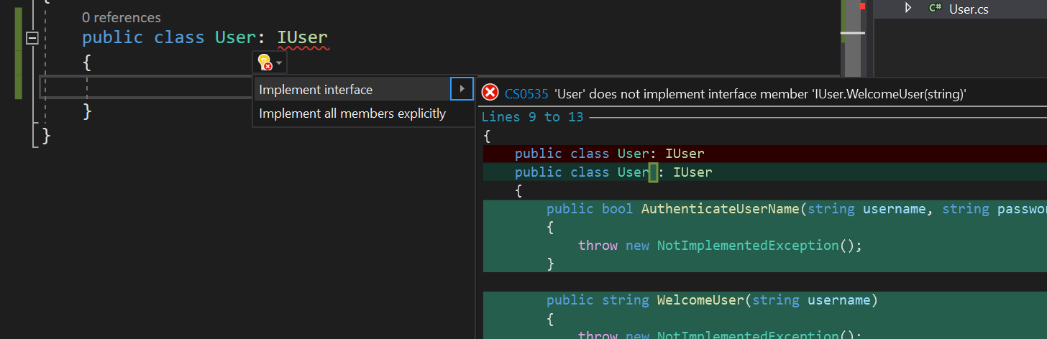

Press on implement interface

Now creating wcf service using predefined template:

Create new project-> wcf service:

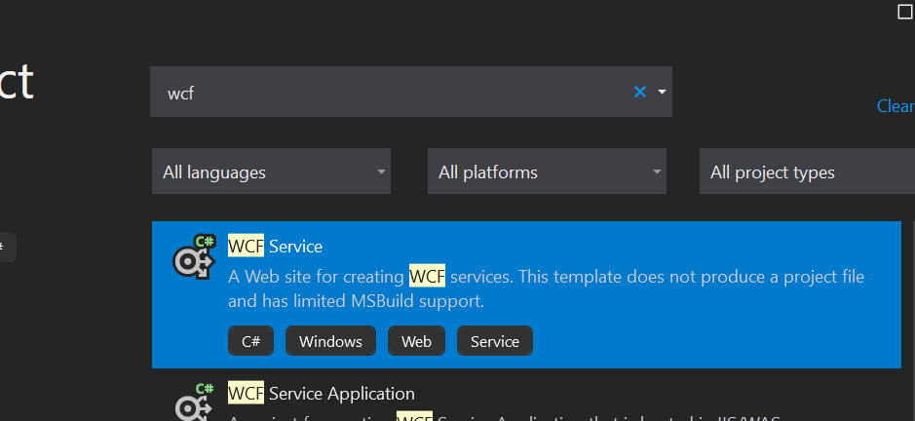

In samplewcfdemo I have got pre built interface code like Iservice and service:

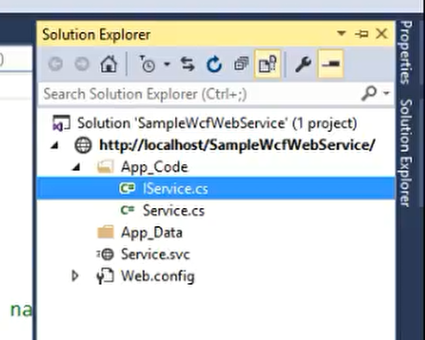

But I’ll delete these 2 and create my own, but in previous project I have created 2 files you can add that to here.

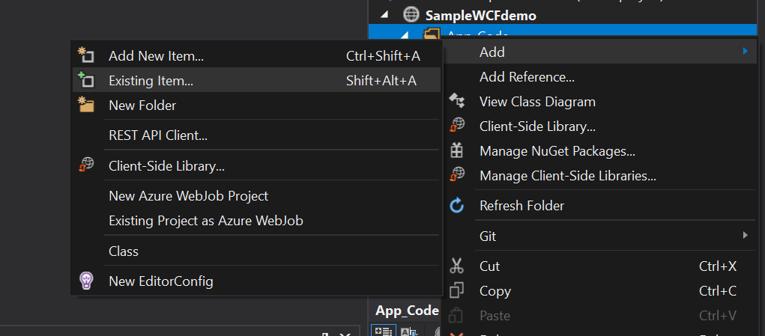

Selecting IUSer AND USER

Next add another class

Service.svc helps you in consuming web service

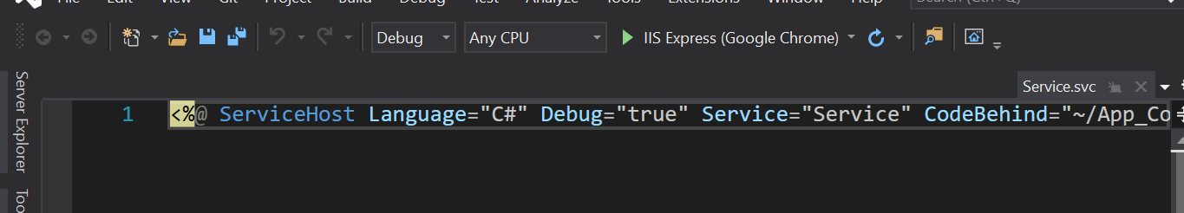

Here I service means class name: change it to User



8: multiple contracts

So far until now while creating wcf service we took single interface with service contract.

Now we’ll create multiple interfaces:

Why: if you want distribute the functionalities differently with different kind of users.

Example within my company if I want tcp protocol should be there so that internal employees can access some of the functionalities, while you want to go for http protocol if you want to distribute the any particular service to the multiple user around the globe so you can create 2 different interfaces in that scenario, we can use different binding technique

To add multiple service contract add another service contract in IUser.cs

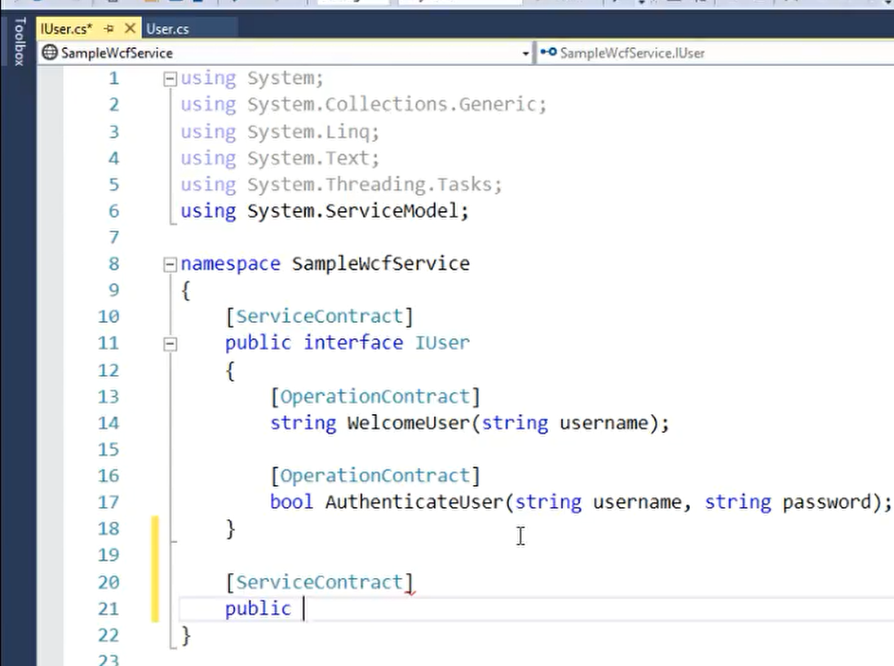

Public interface IUsers

[ServiceContract]

public interface IUsers

{

List<string> GetUserNames();

}

Here Iusers contains method named getusernames, so that any employee working in the domain like internal employee can get the name of all the users whether outside the domain if user wants to login he’ll have mthod like welcomeuser and authenticateuser

So next in User.cs implement method IUSers

***Error* Under samplewcfweservice in service.svc in service: I added previously like this**

Service="SampleWcfService.User"

But IUser and User file’s namespace were different :

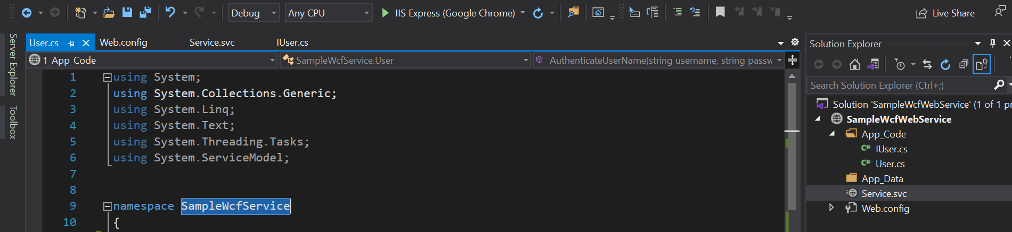

**So then I need to add Samplewcfservice in**

Service=" **Samplewcfservice**.User"

Or else you need to change name of namespace in both IUser and User

That samplewcfwebservice It “”**Samplewcfservice’” changing namespace’s name in IUser and User and service.svc and also in web.config:**

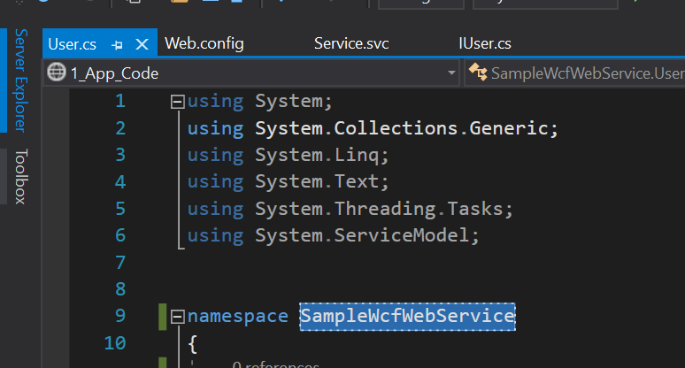

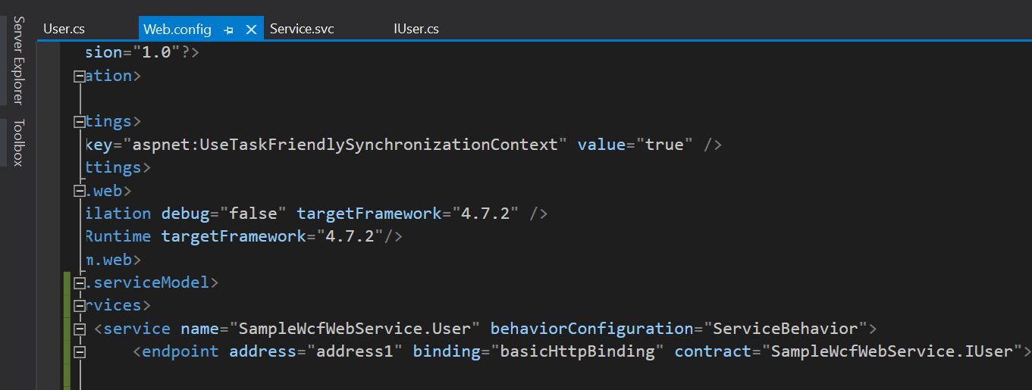

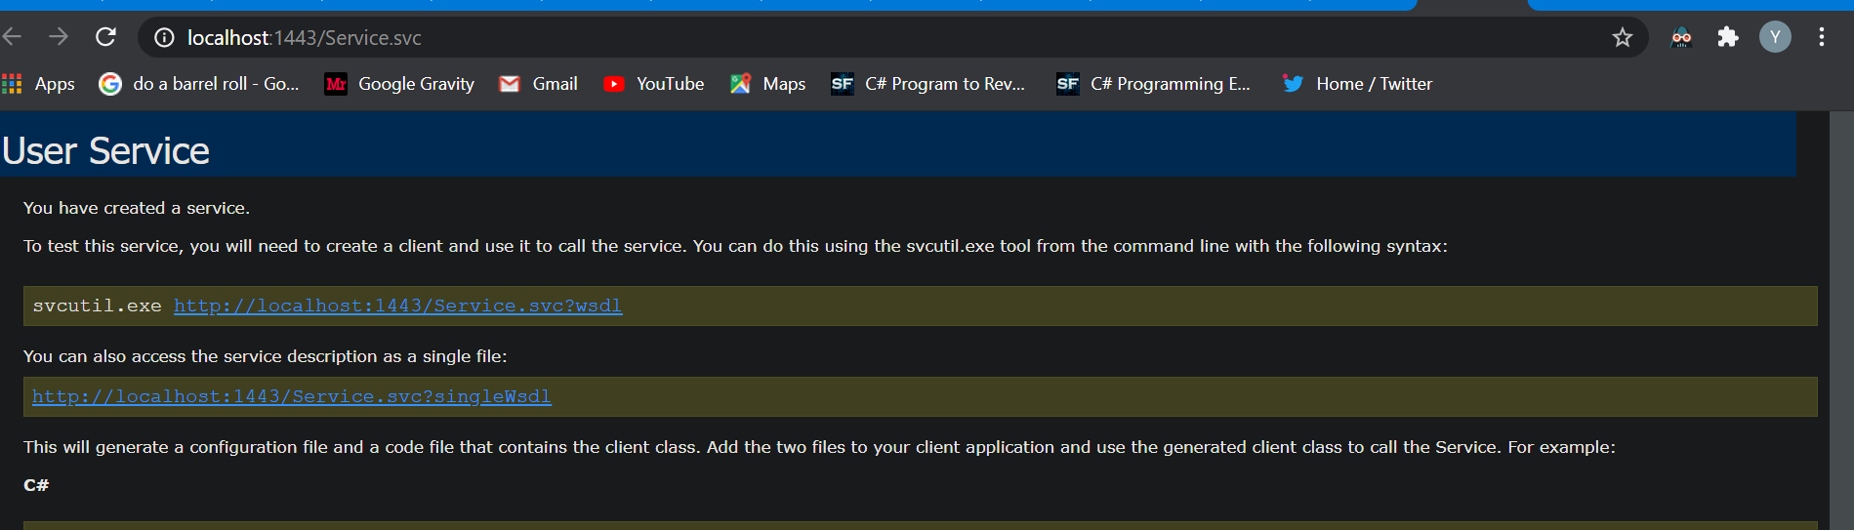

One **wrong thing I did I opened samplewcfservice inside that I clicked right ->add item -> windows forms (user control forms).**

**So when you do like this you won’t see form references.**

**So correct method is open samplewcfservice project->**

**Right click on **

**Not on **

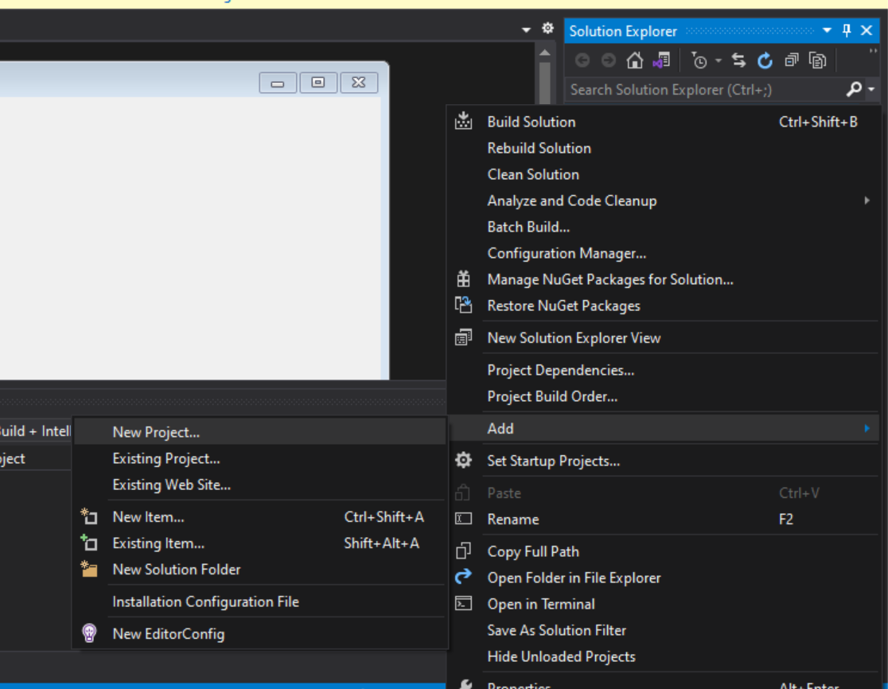

**New project -> search windows forms app -> name it as wcfHost**

One mor mistake I’ve done created wcfhost project outside samplewcfservice.

If you do like this you’ll get 2 problems while adding reference you can’t add samplewcfservice.dll to wcfhost reference another you can’t import

Samplewcfservice in form.cs

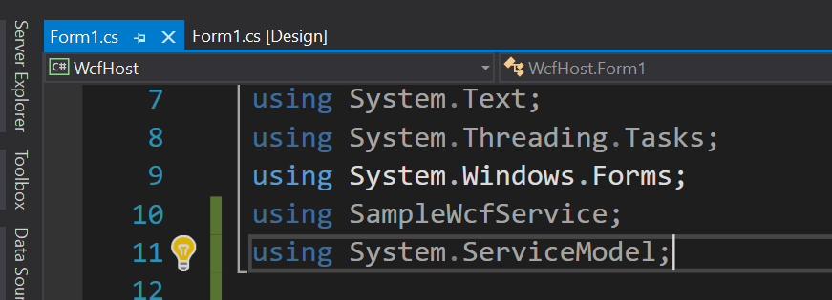

Here I did correct thing so I could able to use using samplewcfservice.

So main thing is here adding path while creating new project wcfhost you need to create it inside samplewcfservice

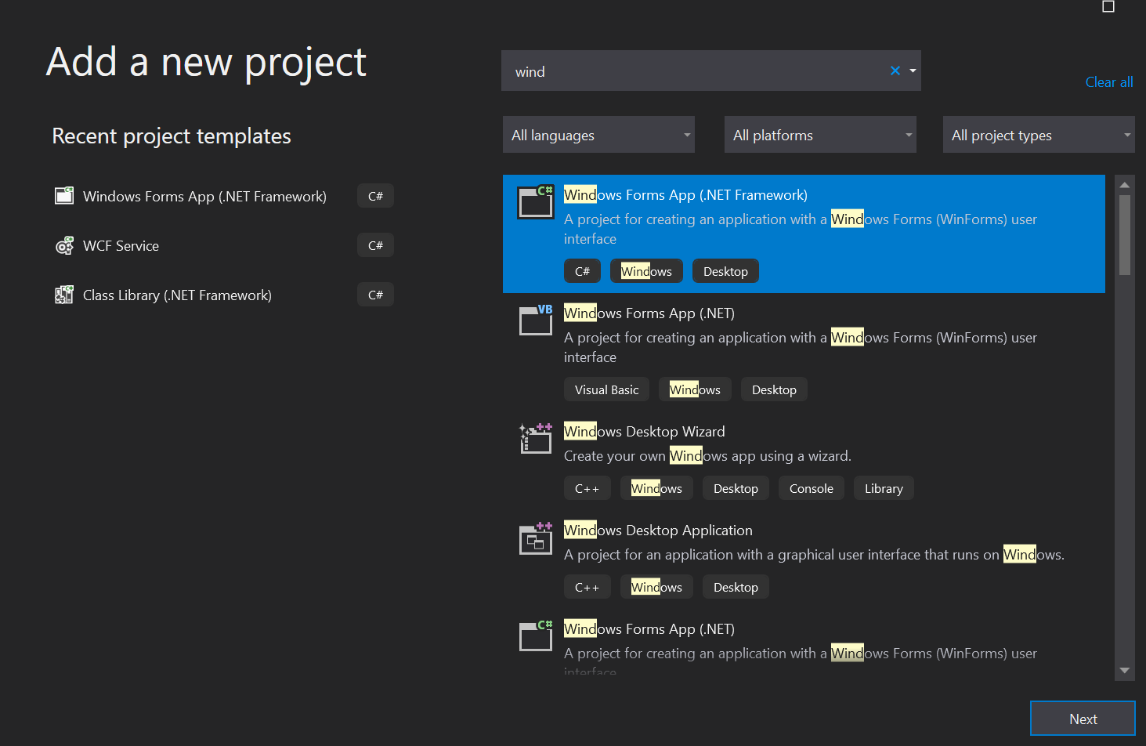

Inside samplewcfservice:

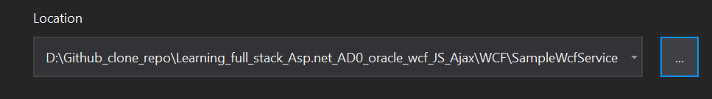

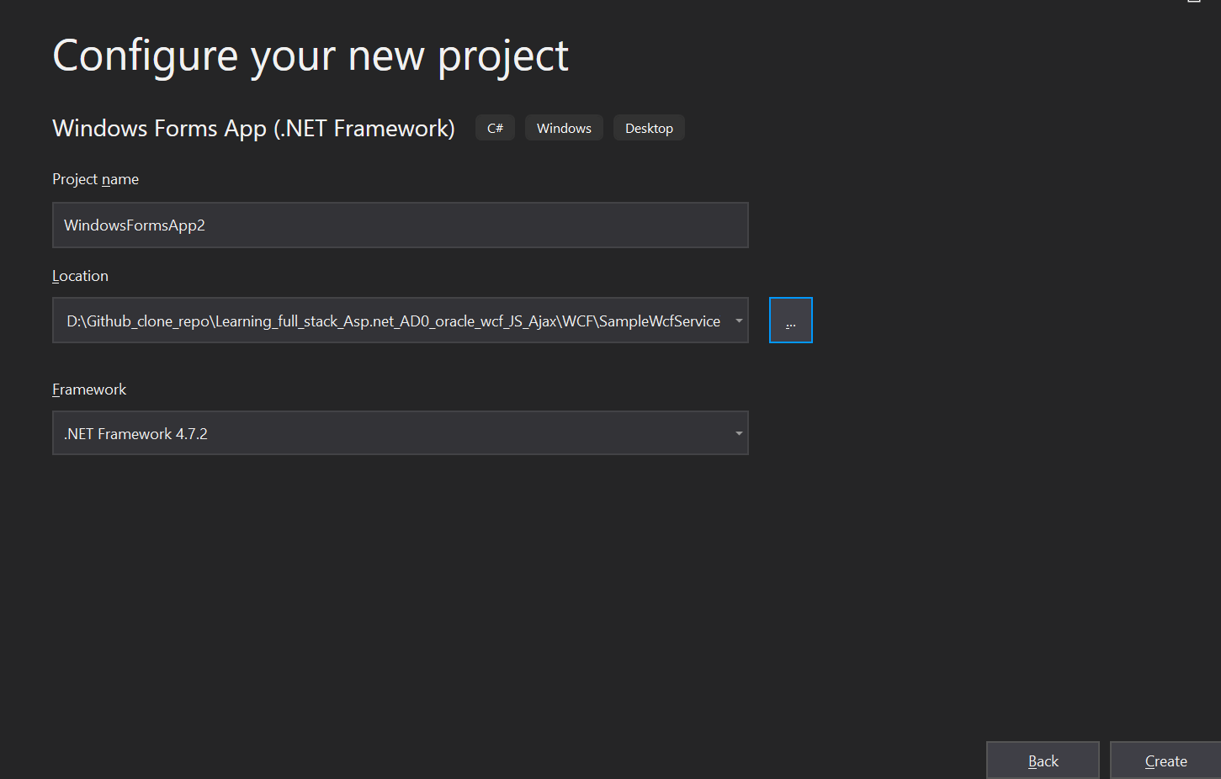

This is very important while creating windows forms.

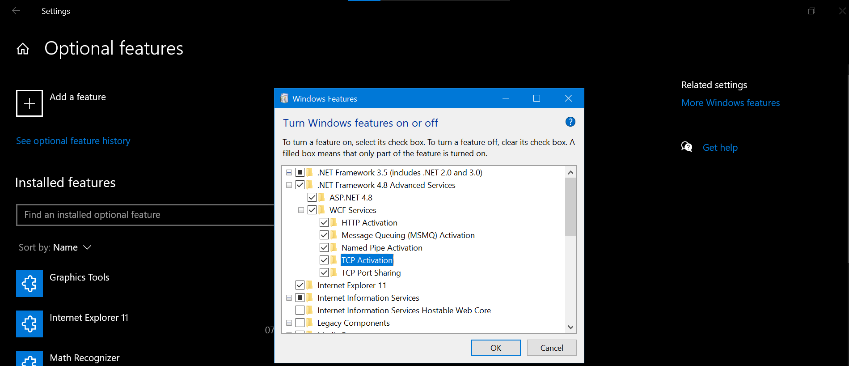

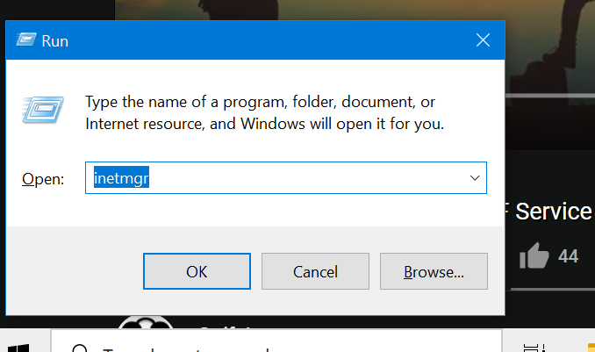

**Hosting wcfwebservice in iis. :** [**https://www.youtube.com/watch?v=mqBlWVaGGgA**](https://www.youtube.com/watch?v=mqBlWVaGGgA)